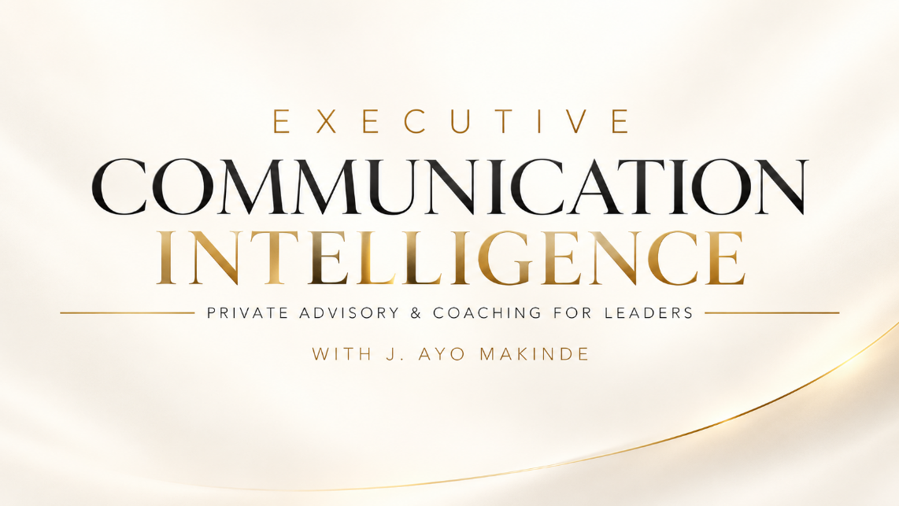
The Higher the Stakes, the More Meaning Matters.

At the highest levels of leadership, communication carries consequences.
A sound strategy can fail through misunderstanding. A necessary decision can create unnecessary resistance. A poorly handled conversation can damage relationships built over years.
And sometimes, the difference between alignment and confusion, commitment and disengagement, or trust and resentment lies not in what a leader communicates, but how, when and through which channel it is communicated.
Executive Communication Intelligence (ECI) is a private advisory and coaching experience designed to strengthen the intelligence, judgement and responsibility with which senior leaders communicate.
Request a Confidential Consultation

Communication Is How Leadership Happens.
Leadership is expressed through decisions, relationships, direction, influence and action. Communication enables these responsibilities.
Every instruction, meeting, conversation, announcement, response and even silence can influence how people understand leadership intentions and respond to them.
Yet executive communication is often taken for granted.
Professional accomplishment does not automatically confer communication intelligence. Neither does positional authority guarantee that a leader understands how their words, behaviour or choice of communication channel affects others.
The higher the authority, the greater the communication responsibility.
ECI helps executives understand how their communication shapes relationships, organisational alignment and leadership effectiveness.
The Hidden Cost of Misunderstanding.
Communication failures rarely appear as separate items on an organisation's financial statements.
Their consequences may nevertheless be significant.
They can emerge through:
- Lost productivity: Misunderstood instructions, repeated explanations, avoidable rework and delayed execution.
- Talent loss: Disengagement, deteriorating relationships and the departure of valuable employees.
- Leadership misalignment: Conflicting interpretations, inconsistent priorities and weakened coordination.
- Eroded trust: Communication behaviour that discourages openness, honest feedback and constructive disagreement.
- Reputational exposure: Poorly managed stakeholder communication or inappropriate responses to sensitive situations.
- Missed opportunities: Delayed decisions, unresolved tensions and ineffective engagement.
These consequences can affect operating costs, institutional performance and the bottom line.
Not every performance problem originates in communication. But communication can enable good decisions to succeed or contribute to their failure.
ECI helps executives identify where communication gaps may be undermining effectiveness and develop the judgment to address them.
Beyond Communication Skills. Towards Communication Intelligence.
Executive communication is not simply about speaking confidently, making compelling presentations or crafting persuasive messages.
It requires an understanding of how people create, convey, interpret and act upon meaning.
It also requires recognising that the method and medium of communication can influence the meaning people receive.
A message delivered through an inappropriate channel may communicate indifference rather than urgency. An instruction issued without sufficient context may produce compliance without understanding. An insensitive response can damage trust even when the underlying decision is justified.
ECI therefore examines executive communication through four interconnected dimensions:
Meaning. Method. Medium. Consequence.
Meaning
What did the leader intend? What did others understand? Where did interpretation diverge?
Method
How was the message communicated? What roles did language, tone, timing, emotional awareness, listening and behaviour play?
Medium
Was the communication channel appropriate to the message, audience, sensitivity and desired response?
Consequence
What happened next? How did the communication influence understanding, relationships, decisions, behaviour and performance?
Communication intelligence is not simply knowing what to say. It is understanding what communication does.
Who ECI Is For
ECI is designed for individuals whose communication carries significant organisational, institutional or public consequences.
Chief Executives and Business Leaders
Strengthening executive judgement, strategic alignment, organisational trust and communication that supports execution.
Board Chairs and Senior Executives
Navigating sensitive relationships, competing interests, difficult conversations and consequential decisions.
Public-Sector and Institutional Leaders
Communicating policies, reforms and institutional priorities with clarity, credibility and awareness of public interpretation.
Founders and Visionary Leaders
Translating personal vision into shared understanding, organisational commitment and coordinated action.
The ECI Philosophy
Intelligence. Responsibility. Effectiveness.
Intelligence: Understand
Recognise how meaning is created and interpreted, understand people and context, and identify communication blind spots.
Responsibility: Own the Process
Exercise communication judgement, emotional discipline, respect and appropriate use of authority, recognising that intentions do not erase consequences.
Effectiveness: Make It Count
Communicate in ways that strengthen understanding, support sound decisions, sustain relationships and enable purposeful action.
Mutual understanding does not necessarily mean mutual agreement. Effective leadership requires the intelligence to recognise the difference.

The Executive Experience
Personal. Confidential. Purposeful.
ECI is not a conventional training programme built around a predetermined curriculum.
It is a personalised advisory relationship focused on the executive's responsibilities, communication patterns, leadership environment and real-world challenges.
Each engagement is designed around five areas.
01 | Executive Communication Diagnosis
A confidential assessment of communication patterns, leadership interactions, stakeholder dynamics, preferred channels and potential misalignment risks.
02 | Private Executive Advisory
Individual advisory conversations examining consequential decisions, difficult relationships, communication challenges and situations requiring considered judgement.
03 | Communication Intelligence Development
Targeted development of self-awareness, listening, emotional regulation, communication judgement, channel selection and responsible influence.
04 | Strategic Application
Applying insights to actual leadership situations, including organisational change, executive alignment, conflict, employee engagement and stakeholder communication.
05 | Progress and Impact Review
Assessing observable changes against agreed priorities and indicators. Depending on the engagement, these may include decision clarity, stakeholder feedback, communication-related rework, leadership alignment and employee experience.
The focus is on practical improvement, not activity for its own sake.
The Engagement
Initial Structure: A personalised 90-day private advisory and coaching engagement.
Format: Confidential individual sessions, diagnostic conversations, targeted practical exercises and progress reviews.
Executive Deliverable: A personalised Executive Communication Intelligence Profile and Development Plan identifying key strengths, communication blind spots, priority risks and recommended actions.
Engagements are selective and individually scoped, reflecting each executive's responsibilities, circumstances and organisational context.
The Executive Advisor
J. Ayo Makinde
Human Communication Intelligence | Strategic Communication | Founder, Goldapples Media
For over three decades, J. Ayo Makinde has worked where communication meets leadership, public perception and institutional responsibility.
His experience across broadcasting, high-level interviewing, media leadership, strategic communication and executive development has shaped a fundamental conviction:
Communication is not simply about delivering messages. It is about understanding how meaning influences people, relationships, decisions and outcomes.
Through ECI, he brings that experience and his work in Human Communication Intelligence, Leadership Alignment and Communication-to-Execution into a deeply personalised advisory relationship with senior leaders.
A Private Invitation
Leadership Carries Consequences. So Does Communication.
The greater your responsibility, the more consequential your communication becomes.
Your decisions matter. Your intentions matter.
But how those decisions and intentions are communicated, understood and acted upon can determine whether leadership produces alignment or resistance, confidence or uncertainty, progress or avoidable loss.
Executive Communication Intelligence
Private Advisory & Coaching for Leaders
With J. Ayo Makinde
A selective, individually tailored executive engagement.
Request a Confidential Consultation

